Mobile doggy parlours:
Yuppi Puppi Mobile Dog & Cat Grooming Contact Symone.
106 Dog breeds and most breed of cat
email yuppipuppi@gmail.com
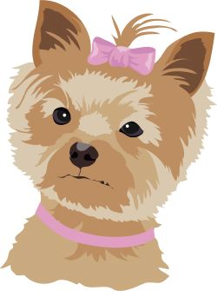
Mobile Doggy Wash & Dip
Contact Amanda 079 110 3056

SYMONE Professional Pet Stylist
078 472 7322
Selected dog breed and most cat breeds
Pawsome Pets
Dog grooming and other pet services
Contact Lindy Rolle
Cell : 082 701 9682 email: lindy.rolle@hotmail.com
DOG PARLOUR:
Waggy Tails
RUIMSIG area. Collect & deliver
011 958 1741 Fax: 086 503 4314

